Assignment- 14.1
2303A52231
Shaik Sohail
BATCH - 44

Lab 14: Web Design Application – AI-Assisted HTML/CSS/JS
Generation

Task 1 – Portfolio Website Design

Prompt: Create a personal portfolio website with About Me, Projects, and Contact sections. Use a modern warm color palette, professional heading/body font pairing, responsive layout using Flexbox/Grid, sticky navigation, and smooth scrolling between sections. Ensure mobile-friendly behavior and clean visual hierarchy.

OUTPUT:

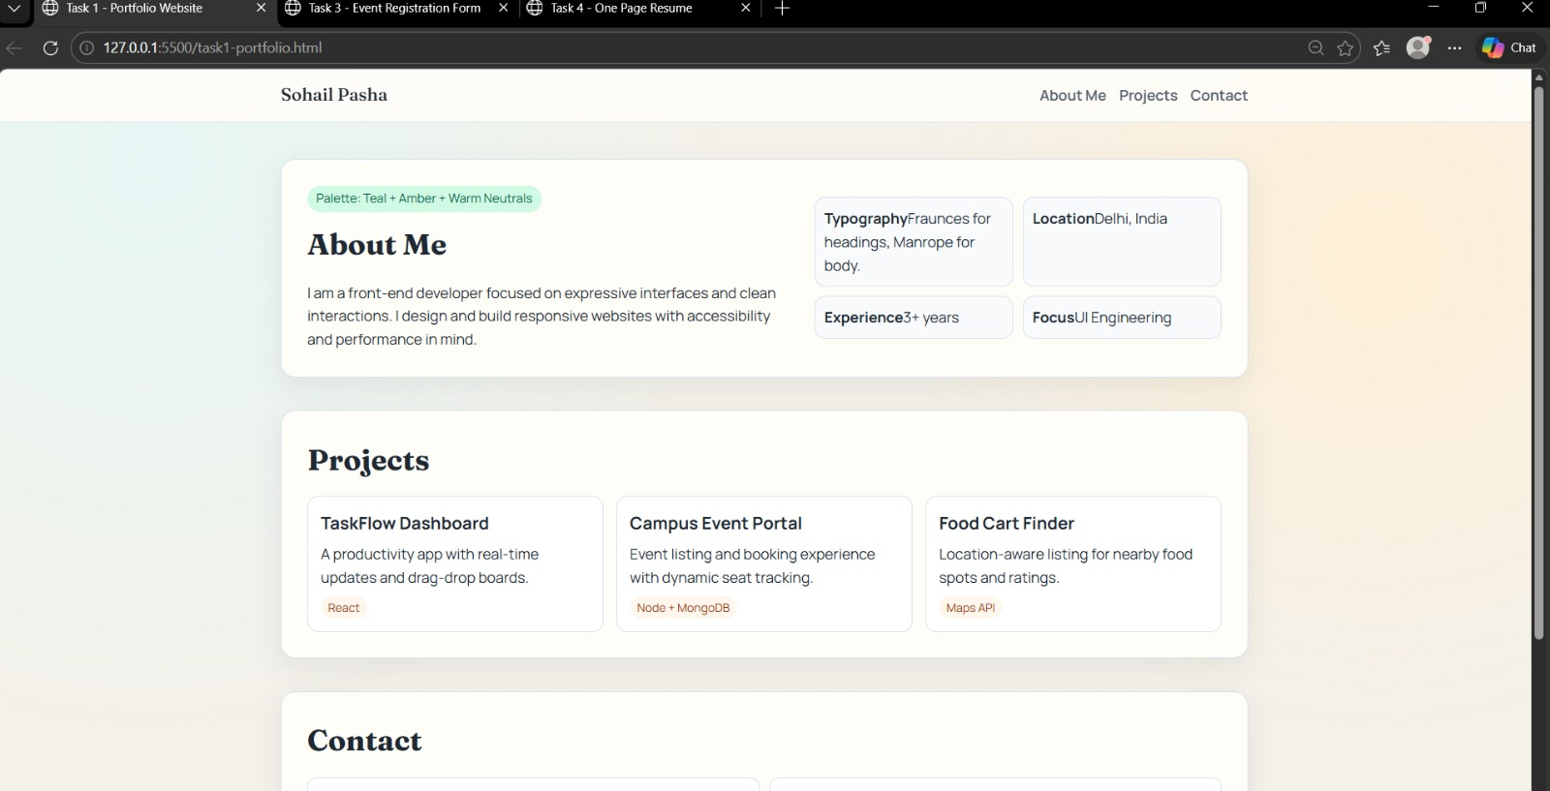
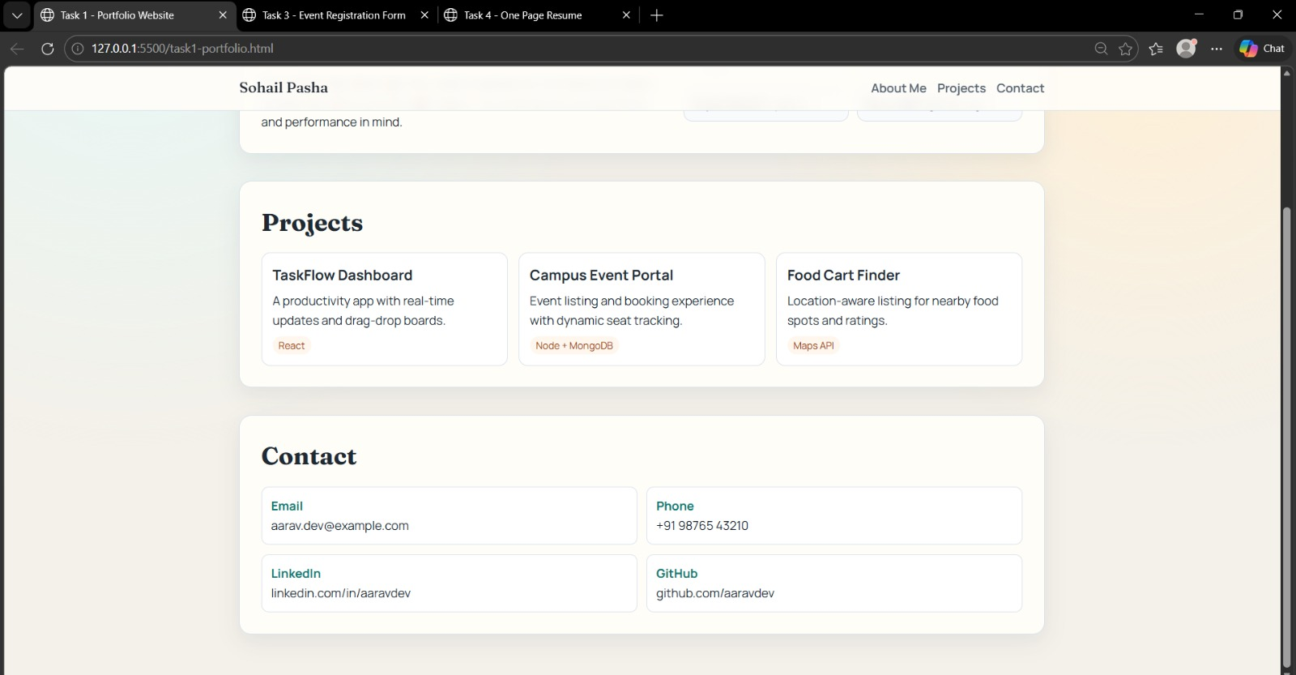

Observation:The layout worked well across desktop and mobile, section navigation felt smooth, and typography improved readability. Grid cards made project content easy to scan, and the sticky menu improved usability.
Task 2: Online Store Product Page
Prompt: Design a single product page for wireless headphones with product image, title, price, description, and Add to Cart button. Use BEM class naming in HTML/CSS, responsive two-column-to-one-column layout, hover effects on image/button, and JavaScript alert on Add to Cart click.
OUTPUT:
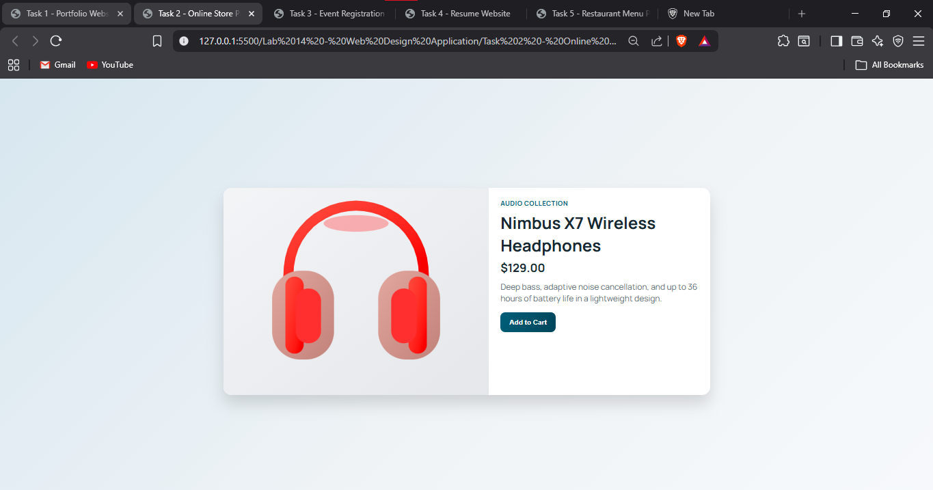
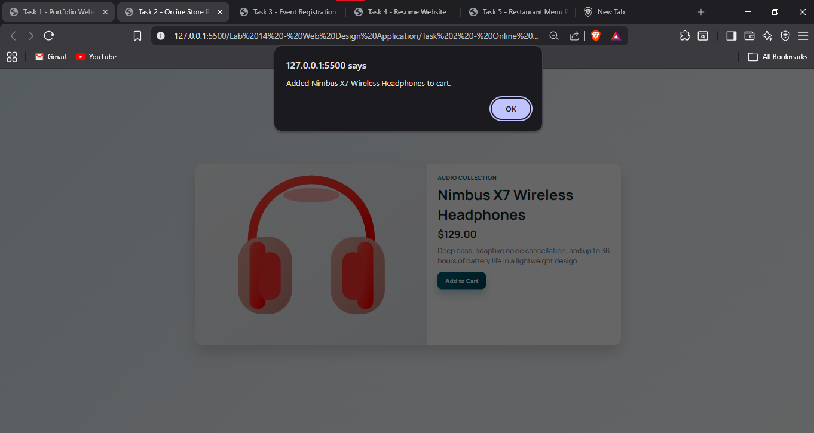
Observation: BEM naming made styling organized and easy to maintain. Hover effects increased interactivity, and responsive behavior preserved structure on smaller screens. Add to Cart interaction confirmed user action clearly.

Task 3: Event Registration Form
Prompt: Build an accessible conference registration form with fields for name, email, phone number, and session selection. Add labels, ARIA attributes, inline validation messages, and JavaScript validation for required fields and format checks. Style with a professional card layout.
OUTPUT:
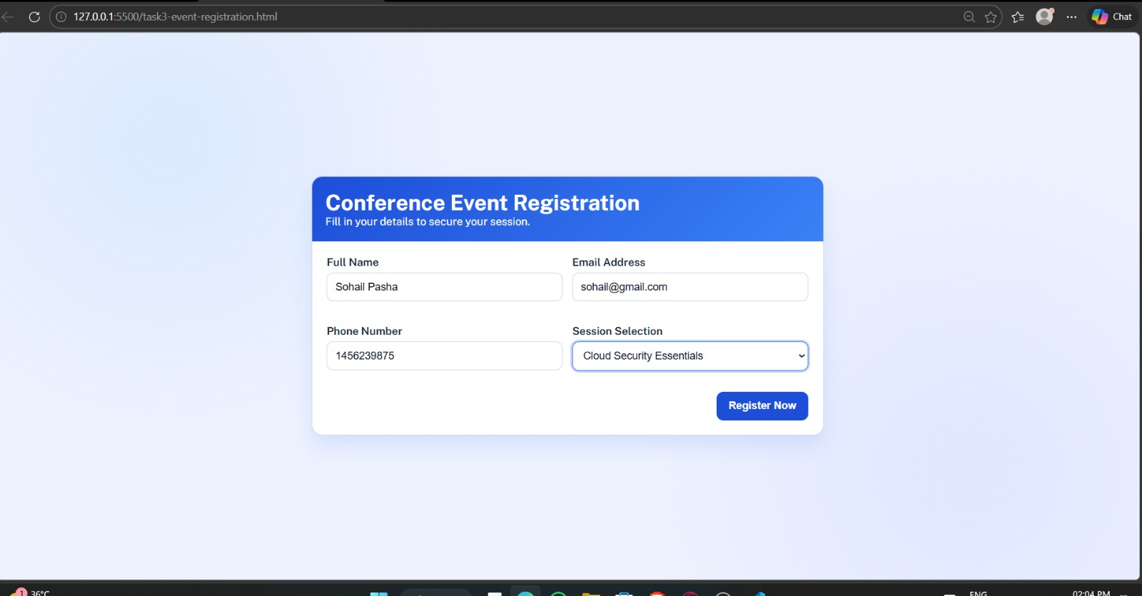
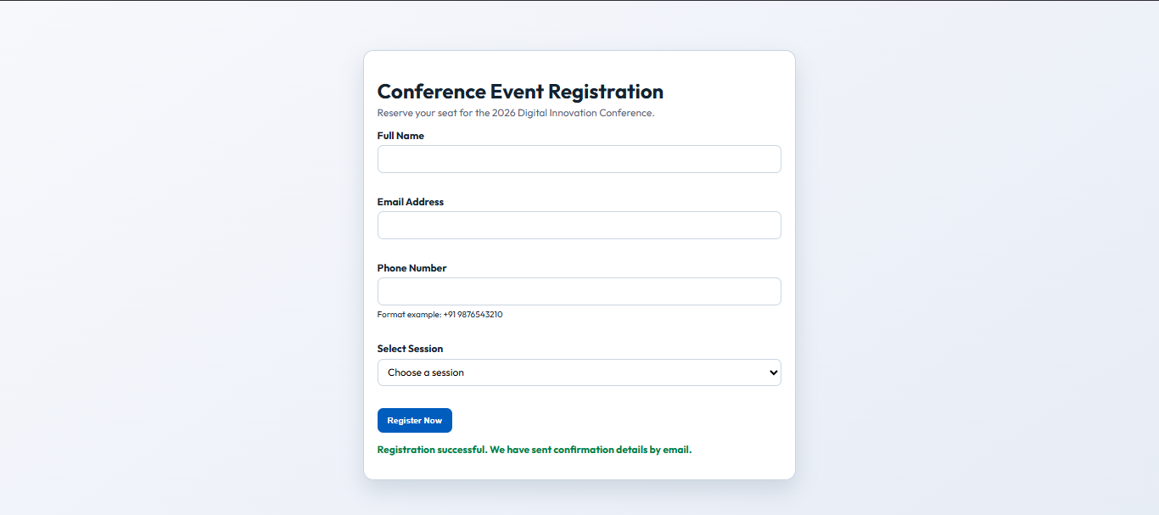
Observation: Real-time and submit-time validation reduced invalid input. Accessibility elements (labels, aria-live messages, required indicators) improved form clarity. The design looked professional and consistent.

Task 4: Resume Website
Prompt: Create a one-page online resume with Profile Summary, Skills, Education, and Experience sections. Use professional typography pairing, align sections with CSS Grid, and implement smooth-scroll navigation links to each section. Keep design clean and recruiter-friendly.
OUTPUT:

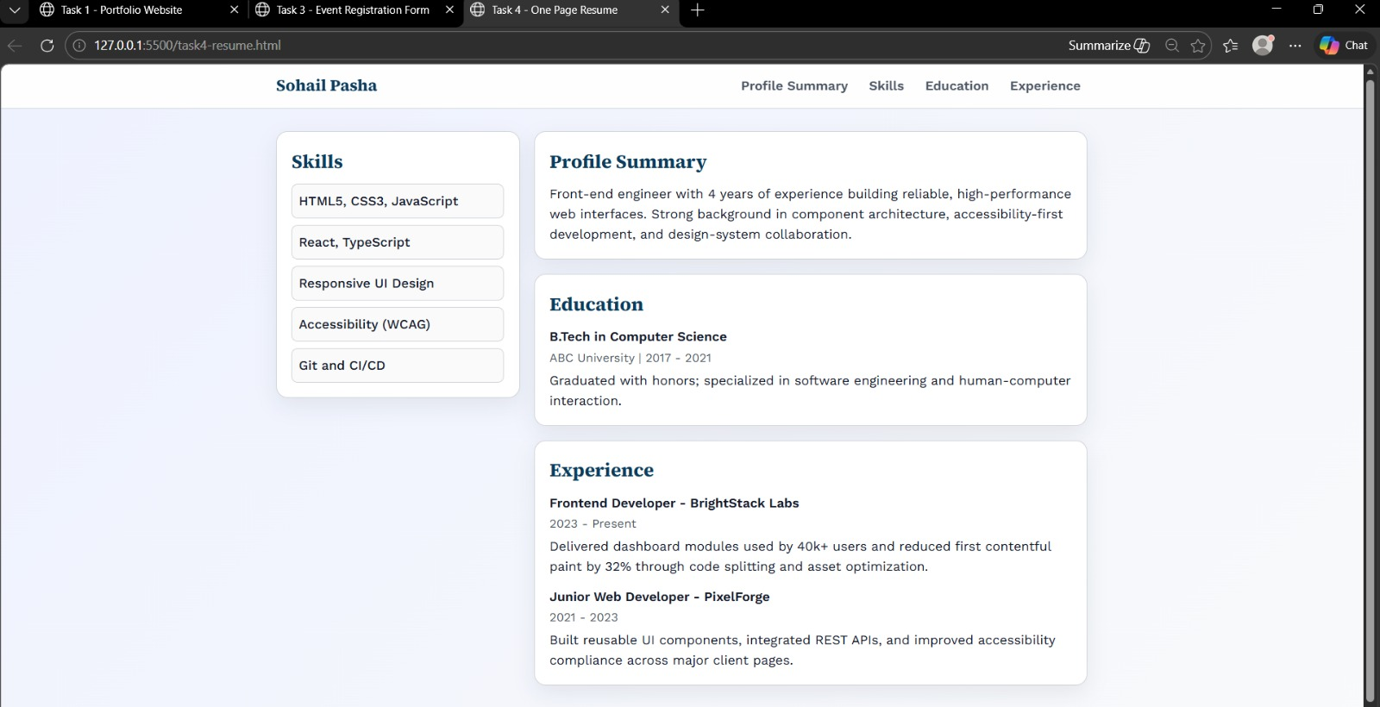
Observation: Grid alignment gave a balanced resume structure and easy scanning. Smooth-scroll links improved movement between sections. Typography choices made headings stand out while keeping body text readable.

Task 5: Restaurant Menu Page
Prompt: Design a digital restaurant menu showing item name, description, and price in responsive cards. Suggest a food-friendly palette (warm earthy tones), create a card-based layout using CSS Grid, and add hover effects to menu cards. Ensure mobile responsiveness.

OUTPUT:
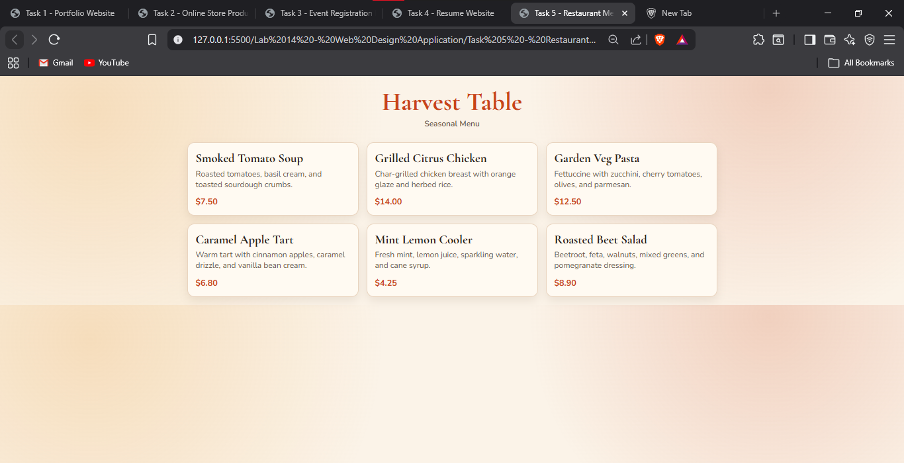
Observation: Warm palette supported the food theme effectively. Card layout made menu items visually clear and adaptable across screen sizes. Hover transitions added polish without distracting from the content.

